# 4COSC008C Trends in Computer Science

# Tutorial 4 Week 5

**Task1**

Complete tasks from the week 4 tutorial, where appropriate.

# Task 2

Work on your presentation topic.

1. Identify keywords from your chosen presentation topic
2. Find up to 3 sources on Library Search [www.westminster.ac.uk/librarysearch](http://www.westminster.ac.uk/librarysearch) (a combination of a book, a journal article, a dictionary, encyclopaedia or handbook entry, or quality information on the Internet). You can use <https://libguides.westminster.ac.uk/referencing/home>

and all resources mentioned in lecture 4.

1. Write down the references for the sources you have found. Use Cite Them Right for help. Remember that your sources should have the form

Surname, I(nitial). (Date) Title Location: Publisher. Share one example with the members of your group.

For your coursework you can use either an alphabetical system, such as Westminster Harvard, or a numerical system such as IEEE.

1. Based on the feedback you received from your first example, share with your tutor all three examples of sources you have identified.

# Task 3

Now consider more closely the sources you have identified. Are they accurate? Credible? Current? Why will they be useful for your work?

Present orally one of your sources to the full tutorial group and explain why this source will be useful to your work (approximately 1 minute per student- rehearsal presentation).

# Task 4

Consider the CW1 presentation marking scheme and discuss any questions you might have.

# Task 5

In your opinion, what are the characteristics of a successful presentation?

Work on your presentation’s structure (e.g. Slides’ titles) and share its draft structure with your tutor. Your presentation slides (or similar) should include:

* An initial slide with your group details, your name, the title of your presentation and the code and title of this module.
* An Introduction slide (Title: 1. Introduction).
* A slide (or two)discussing the first half of your question, adapted where appropriate (2. …).
* A slide (or two) discussing the second half of your question (3. …)
* A slide presenting your critical evaluation and conclusion (4. Conclusion)
* A slide presenting your References (References).

Then work on its content. You should take the opportunity to share with your tutor your draft presentation during next week’s tutorial.

In-text Citation examples

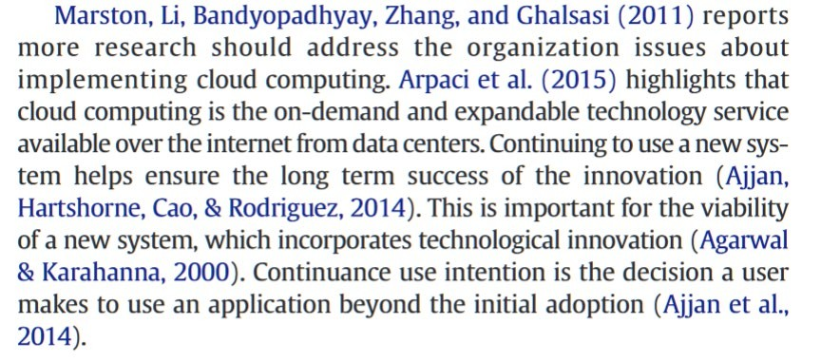

Reference List Examples

Dale, N. and Lewis, J. (2016). *Computer science illuminated*. 2nd ed. Burlington, MA: Jones & Bartlett Learning.

Goldacre, B. (2015). *I did a Newsnight thing about how politics needs better data.* Bad Science. Available from [https://www.badscience.net/2015/02/i-did-a-newsnight-thing-about-how-politics-](https://www.badscience.net/2015/02/i-did-a-newsnight-thing-about-how-politics-needs-better-data/) [needs-better-data/](https://www.badscience.net/2015/02/i-did-a-newsnight-thing-about-how-politics-needs-better-data/) [Accessed 12 March 2015].

Greengard, S. (2015). *The internet of things.* Cambridge, MA: MIT Press. Available from [https://search.ebscohost.com](https://search.ebscohost.com/) [Accessed 27 January 2022].

Kessler, G.C. (2022). *GCK’s file signatures table.* Gary Kessler Associates*.* Available from <https://www.garykessler.net/library/file_sigs.html> [Accessed 27 January 2022].

Roast, C. (2012). Constraining and creating solutions: reflections on the analysis of early design. In: Winckler, M. Forbrig, P. and Bernhaupt, R., eds. *Human-centred software engineering: 4th international conference, HCSE 2012*. Toulouse, France. 29-31 October 2012. Heidelberg: Springer, 130-145.

Shein, E. (2021). A battery-free internet of things. *Communications of the ACM,* 64(7), 16-18. Available from <https://doi.org/10.1145/3464937> [Access 27 January 2022].

# Can you tell what type of resources are being used?

**Independent study**

1. Consider the following:
   1. The British Computer Society Professional Code of Conduct <https://www.bcs.org/membership/become-a-member/bcs-code-of-conduct/>
   2. The information provided by the Information Commissioner’s Office on Data Protection. <https://ico.org.uk/your-data-matters/>
2. Work on your presentation content